Assignment 2

Name: Dylan Francis
Student Number: 215008243
Date: 27/08/2019

I declare that this is my own, original work.

Signature: _________________

Implementation Details

Stopping Conditions:
Initial Weights: Uniform random numbers between -1 and 1
Training Set size: 2361 (20%)
Test Set size: 674 (70%)
Values for η investigated: 0.1x10⁻⁶
0.1x10⁻⁷
0.1x10⁻⁸
0.1x10⁻⁹
0.1x10⁻¹⁰
Activation functions: Sigmoid (Hidden) and Linear (Output)
Number of hidden neurons: 4 – 5

Write a paragraph on the network morphology, focusing on what inputs are provided to the network and what is given as output.

Network Morphology

The network takes in the following 6 inputs:

- Year, reduced to a small integer by subtract 1999;
- Month, used categorically;
- Day of month, used as-is;
- Day of week, used categorically; and
- Previous day’s average, if a day does not have a previous it is removed.

Each input is passed to its own sigmoid neuron in the hidden layer. Each hidden neuron outputs to every output neuron. There are 24 output neurons, one for each hour of a day. Output neurons fire linearly, and their outputs are multiplied by 10. Only output neurons have a bias that is updated.

Results

Number of iterations (typically):
Best η value:
Sum Squared Error (SSE) on Training Set:
SSE on Test Set:
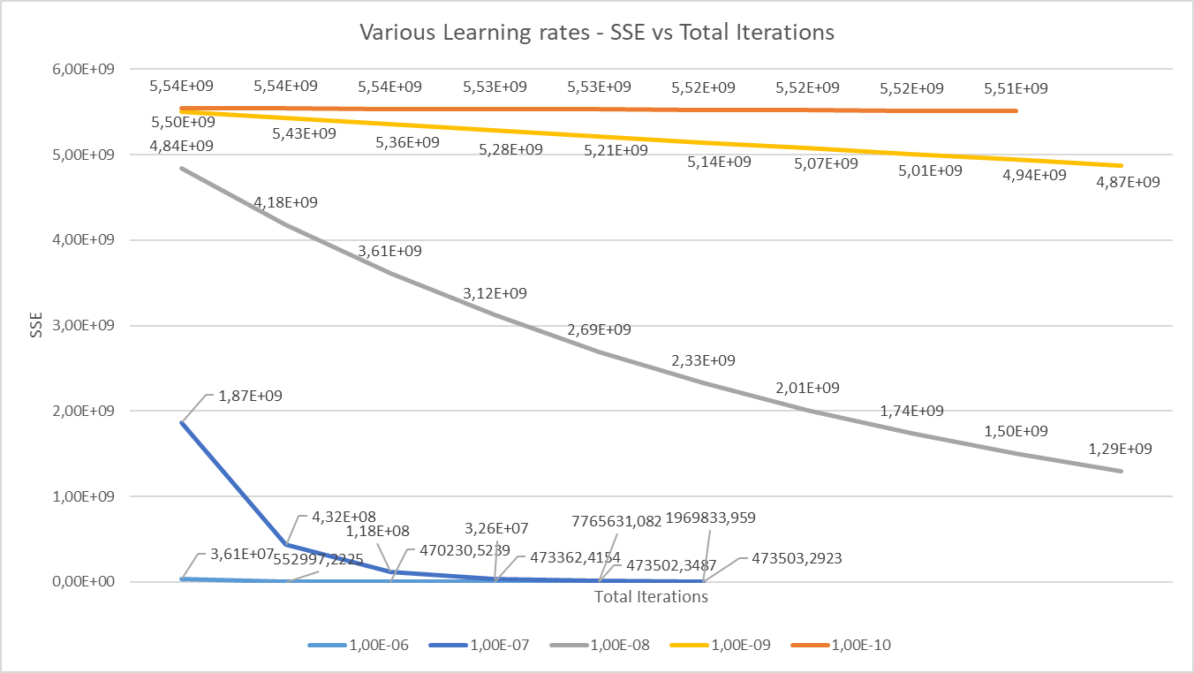

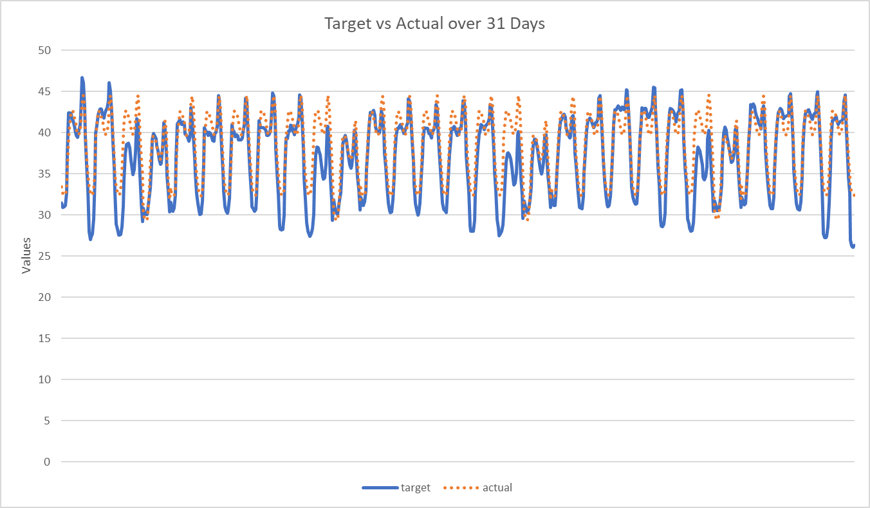

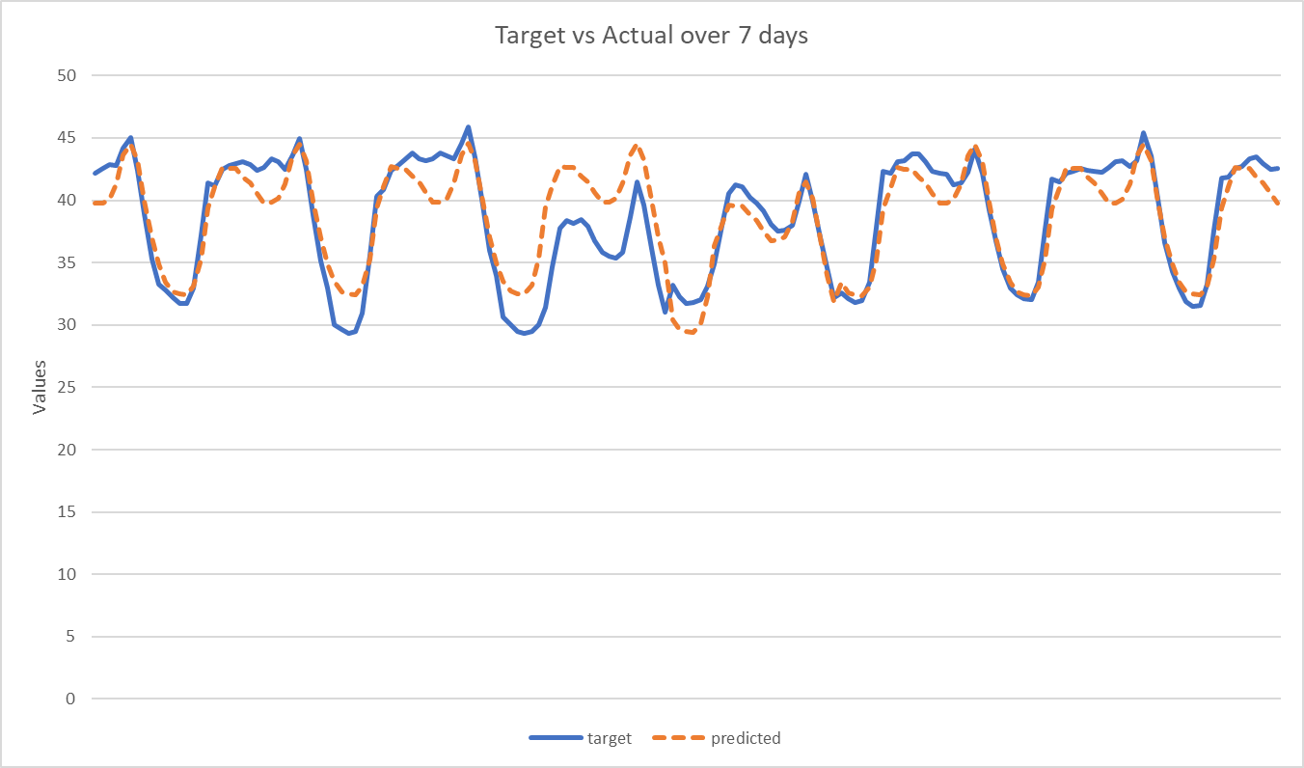

Investigated Techniques

Additional Techniques Investigated:

Technique | SSE on training set | SSE on test set
Momentum
Appropriate Weight Initialisation

Figure 3: SSE vs iterations for the three techniques

Observations

Write a few paragraphs on what you have learned about the training of a neural network. How well do you think it solved the problem?

